MACH4METAL

metalworking machinery
Transito 21,
6909 DA BABBERICH
Netherlands
Tel. +31 (0)316 – 247123
Fax. +31 (0)316 - 247956
info@mach4metal.com
www.mach4metal.com

Bank No : 66.52.13.883
IBAN : NL33 INGB 0665 2138 83
BIC : INGBNL2A

VMC VICTOR VCENTER 105

- Make : VICTOR Taiwan
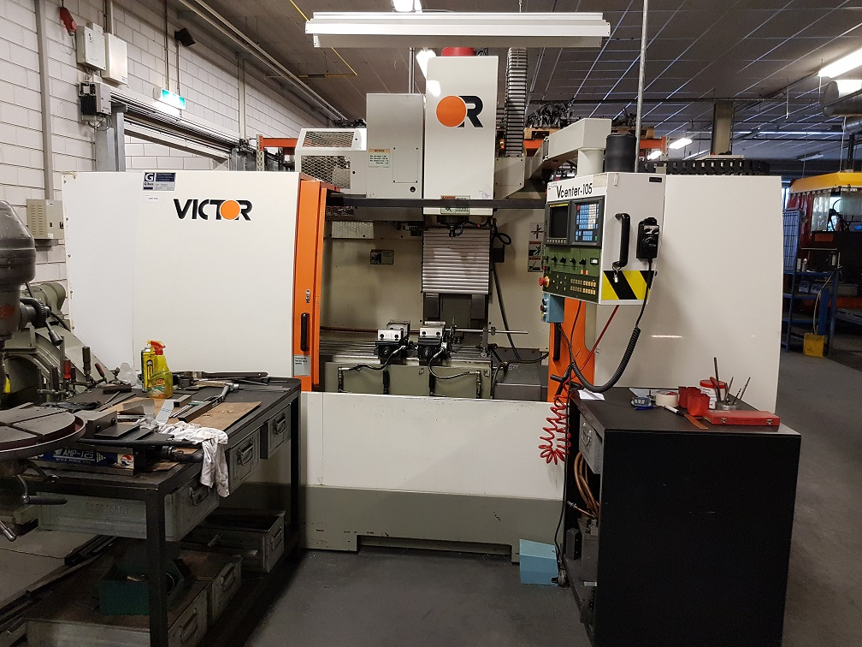
- Type : Vcenter 105
- Serial :
- Age : 2000

- Capacity
- X Travel : 1.050
- Y Travel : 560
- Z Travel : 560

- Table length : 1.400
- Table width : 550
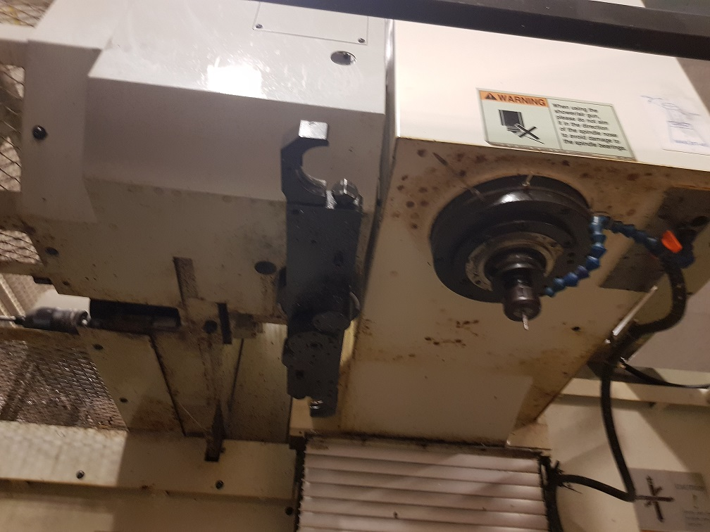
- Table load : 750 Kg

- Spindle taper : Sk 40
- Spindle speeds : 6.000 Rpm

- High pressure coolant true spindle

- Feeds :
- Rapid :

- Dimensions
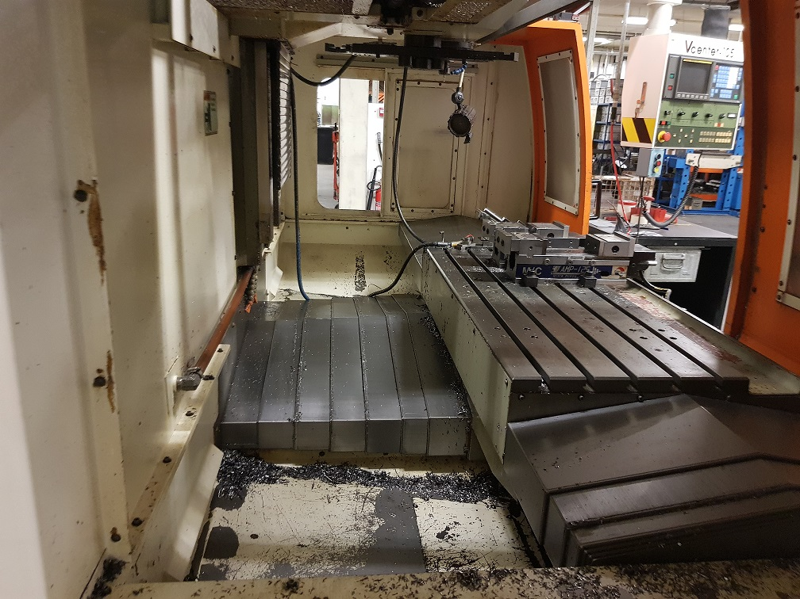
- Length : 4.500
- Width : 2.800
- Height : 2.800
- Weight : 8.200
- Power :

- ATC Tool changer 32 positions
- Gear box spindle drive
- FANUC

Please Note: The above information has been obtained to the best of our ability and belief from, and from the manufacturers where possible. It is given in good faith, but its accuracy can not be guaranteed. Accordingly, it will not form a representation or constitute contractual terms. We advise you to check any vital details!

